Name: _______________________________________________ Period: ______________

HOMEWORK 5.1 Graphing Translations of Radical Functions
Graph each function and identify the domain and range in set and interval notation.
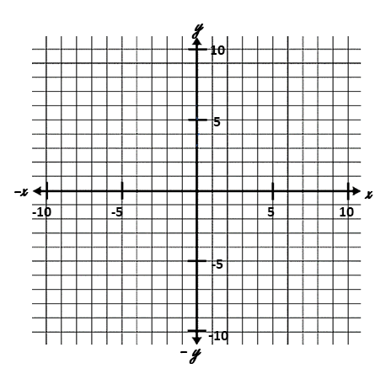


1. $f\left(x\right)= \sqrt{x-4}$ 2. $f\left(x\right)= \sqrt{x-2}+ 5$ 3. $y= \sqrt{x+2}- 3$

D___________________________ D__________________________ D__________________________
R___________________________ R__________________________ R__________________________



4. $f\left(x\right)= \sqrt{x}+ 5$ 5. $f\left(x\right)= \sqrt{x-4}- 2$ 6. $y= \sqrt{x+2}+4$
D___________________________ D__________________________ D__________________________
R___________________________ R__________________________ R__________________________

Using the graph of $f\left(x\right)= \sqrt{x}$ as a guide, describe the transformation.
7. $g\left(x\right)= \sqrt{x+8}$ _______________________________________________________________

8. $g\left(x\right)= \sqrt{x}+ 2$ _______________________________________________________________

9. $g\left(x\right)= \sqrt{x-2}+ 2$ _______________________________________________________________

Use the description to write the resulting square root function g(x). Then write $g(x)$ in terms of $f(x)$.
10. The parent function $f\left(x\right)= \sqrt{x}$ is translated down 3 units.

11. The parent function $f\left(x\right)= \sqrt{x}$ is translated 2 units to the right.

12. The parent function $f\left(x\right)= \sqrt{x}$ is translated down 3 units and to the left 3 units.

13. The parent function $f\left(x\right)= \sqrt{x}$ is translated to $g\left(x\right)=f\left(x+1\right)-3$. Write the new equation and describe the translation.

